|  |
| --- |
| VALUES AND ETHICS  FOUNDATIONS FOR EMPLOYEES |
|  |
| Alternative Version  **Version : July 2021** |
|  |
| © Canada School of Public Service (2021, revised in 2021) |

# Table of content

Table of content 3

Introduction 5

Context 5

Overview 5

Ethical Dilemma 6

Public Sector Values 8

Activity 1 Ethical Dilemma 9

Question 1 9

Question 3 10

Ethical Reasoning Model 10

Annex 1 – Answer keys 11

Question 1 11

Question 2 11

Question 3 11

# Introduction

## Context

Did you know that there is a Values and Ethics Code that is a condition of employment for all public sector employees?

Discover how the federal public sector trains its new employees in workplace values and ethics.

High standards, such as respect, integrity and stewardship, guide public sector employees in their daily work and are also aligned with what Canadians expect of their public servants.

**Welcome**

Welcome to Values and Ethics Foundations for Employees (C255), an online self-paced course.

Canadians have high expectations that their government will be fair, honest and accountable for its actions. It is essential that the government maintain the public’s trust and confidence.

As public servants, we are guided in our daily tasks by the *Values and Ethics Code* for the Public Sector[1], the *Policy on People Management[2]* and the *Directive on Conflict of Interest[3]*, and our individual departmental codes of conduct. These documents are at the heart of the work we do.

In committing to the public service, you will find meaning and a sense of satisfaction. The rewards come from a sense of being in the service of Canada and contributing to the well-being of our fellow Canadians.

Use the navigation buttons on this page to access the help, resources and glossary feature of this course.

## Overview

In the following modules, you will be presented with workplace scenarios that raise ethical questions.

The Values and Ethics Code for the Public Sector provides an understanding of the core values of the federal public sector, thereby helping to maintain the public’s trust.

This is why the [*Code*](https://papp.csps-efpc.gc.ca/ProdContent/cninv000000000015218/index_en.html?state=m0-2#glossary_code)is one of the terms and conditions of your employment.

Let’s explore how we can all contribute to establishing an environment that is based on strong ethical values and fostering a healthy workplace.

## Ethical Dilemma

### What would you do?

Read the transcript of the video.

### What Is Ethics?

Before we go any further, it is important that we are all “speaking the same language,” so here are a few key definitions that we use in the public sector, and that you need to know.

**Values** are the beliefs that influence the ideas, options, actions, choices and decisions we make.

**Ethics** refers to what we ought to do - doing what is right. The ethics of our work environments are based on the organizational values in place and on our responsibilities as public servants, and they involve a commitment to do the right thing.

An ethical dilemma arises when you are unsure of the right thing to do, and your own ethical beliefs are tested.

The federal government provides tools and guidelines to help you make appropriate decisions that are consistent with public sector values.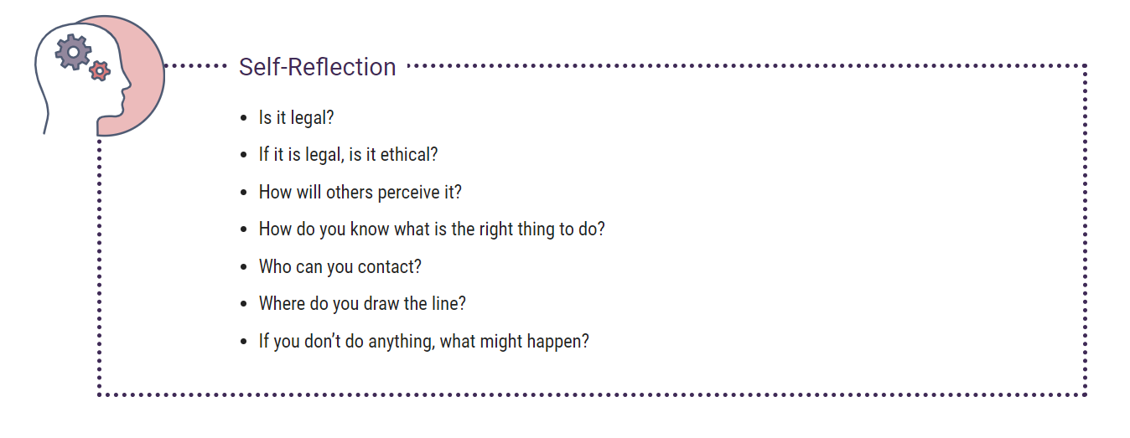

**Types of Values**

Our employer has identified its own organizational values and related behaviors which are outlined in the *Values and Ethics Code for the Public Sector*. The five values of the public sector are: Respect for Democracy, Respect for People, Integrity, Stewardship, and Excellence.

In addition, your department/agency has created its own code of conduct consistent with the public sector code, and it may contain additional values that are important to the environment in which you work.



**Organizational values** are principles that determine an organization’s internal conduct; they influence its dealings with the outside world and how it conducts business and treats its employees. They can include things like fairness, healthy workplaces and transparency.

**Personal values** are not common to everyone; they are influenced by your family, your environment, your culture, your personal experiences, and your religious and political beliefs. They can include things such as lawfulness, loyalty and respect.

## Public Sector Values

We work in an environment that is constantly evolving and where there are many internal and external pressures, including limited resources, complex responsibilities, globalization and public scrutiny.

We are expected to conduct ourselves in accordance with the following public sector values and expected behaviors:

|  |  |
| --- | --- |
| **Public Sector Values** | |
| **Respect for democracy** | The system of Canadian parliamentary democracy and its institutions are fundamental to serving the public interest. Public servants recognize that elected officials are accountable to Parliament, and ultimately to the Canadian people, and that a non-partisan public sector is essential to our democratic system. |
| **Respect for people** | Treating all people with respect, dignity and fairness is fundamental to our relationship with the Canadian public and contributes to a safe and healthy work environment that promotes engagement, openness and transparency. The diversity of our people and the ideas they generate are the source of our innovation. |
| **Integrity** | Integrity is the cornerstone of good governance and democracy. By upholding the highest ethical standards, public servants conserve and enhance public confidence in the honesty, fairness and impartiality of the federal public sector. |
| **Stewardship** | Federal public servants are entrusted with the responsible use and care of public resources in both the short and long term. |
| **Excellence** | Excellence in the design and delivery of public sector policy, programs and services is beneficial to every aspect of Canadian public life. Engagement, collaboration, effective teamwork and professional development are all essential to a high-performing organization. |

## Activity 1 Ethical Dilemma

For each of the following scenarios, select the competing public sector values.

## Question 1

A policy analyst has recommended a course of action to the minister which the analyst believes will result in a better environmental outcome for a long-term initiative. However, another course of action is chosen.

What values are in conflict for this analyst?

1. Respect for Democracy versus Stewardship

2. Integrity versus Excellence

3. Respect for People versus Excellence

4. Stewardship versus Excellence

Answer question 1

### Question 2

An unemployed single father of three children is short one week of employment in order to qualify to collect employment insurance (EI). The EI officer knows this is a special hardship case and would like to make an exception. He is considering altering the dates slightly on the applicant’s form.

What values are in conflict for this EI officer?

1. Respect for Democracy versus Stewardship

2. Integrity versus Excellence

3. Respect for People versus Excellence

4. Stewardship versus Excellence

Answer question 2

## Question 3

An employee tasked with securing an external contract for the printing and distribution of promotional material has been told by her brother-in-law that his company has developed an innovative printing method that will be less expensive and look better.

What values are in conflict for this employee?

1. Respect for Democracy versus Stewardship

2. Integrity versus Excellence

3. Respect for People versus Excellence

4. Stewardship versus Excellence

Answer question 3

## Ethical Reasoning Model

The ethical reasoning model is a process that can help you think through an ethical dilemma. There are various models available in government, but they all have the same basic elements. The following model is one such example.

Consider the following steps when trying to work through an ethical dilemma

# Annex 1 – Answer keys

Quiz 1

## Question 1

**Respect for Democracy versus Stewardship**

Loyally carrying out the lawful decisions of leaders and ministers in their accountability to Parliament and Canadians may at times be in conflict with considering the present and long-term effects that actions have on people and the environment.

## Question 2

**Respect for People versus Stewardship**

Treating every person with respect and fairness may at times be in conflict with being entrusted with the use of and care for public resources

## Question 3

**Integrity versus Stewardship**

Acting at all times in a manner that will bear the closest public scrutiny and taking all possible steps to prevent and resolve any real, apparent or potential conflicts of interest between a public servant’s official responsibilities and their private affairs in favour of the public interest may at times be in conflict with effectively and efficiently using the public money, property and resources managed by them.

1. <https://www.tbs-sct.gc.ca/pol/doc-eng.aspx?id=25049>
2. <https://www.tbs-sct.gc.ca/pol/doc-eng.aspx?id=32621&section=html>
3. <https://www.tbs-sct.gc.ca/pol/doc-eng.aspx?id=32627>